CS 470 Module Two Assignment Two Guide

Introduction

In this lesson, you will complete your work with containers. The lesson introduces Docker Compose, which allows you to orchestrate multiple containers as a logical unit. You will bring up the entire stack in three containers that work together to serve a full stack application.

Summary Steps

- Create a shared network:
  - Create a new bridge network using docker network create --driver bridge lafs-net.
- Create a Docker Compose script for the backend containers:
  - Create a docker-compose YML file in top-level lafs-api directory.
  - Bring up the containers using docker-compose up.
  - Edit lafs-api/server/datasources.development.js to add default local values.
  - Bring up the containers using docker-compose up.
  - Navigate to http://localhost:3000/explorer to verify and add data.
  - Use Mongo shell or Robo 3T to verify the data stored in the Mongo container.
- Create a Docker Compose script for the frontend container:
  - Create a docker-compose YML file in top-level lafs-web directory.
  - Edit lafs-web/src/environments/environment.ts to use localhost:3000.
  - Bring up the container using docker-compose up.
  - Navigate to http://localhost:4200 to verify and add data.
  - Use Mongo shell or Robo 3T to verify the data stored in the Mongo container.

Detailed Steps

Docker Network

As you discovered in the previous assignment, every container is isolated. There are three common ways for the applications in the container to interact with resources outside of the container:

- Use port mapping to allow network traffic from the host computer into the container.
- Use Docker networking to build a virtual network between containers.
- Use Docker volume management to mount storage volumes into the container.

You practiced using port mapping in Module Two Assignment One. Volume management will not be covered in this exercise. You will build a bridge network for the containers to communicate with each other.

Make sure the Docker application is running before you start. Create a new bridge network using the Docker network commands below. To learn more, visit the Docker Network webpage.

> docker network create --driver bridge lafs-net
> docker network list

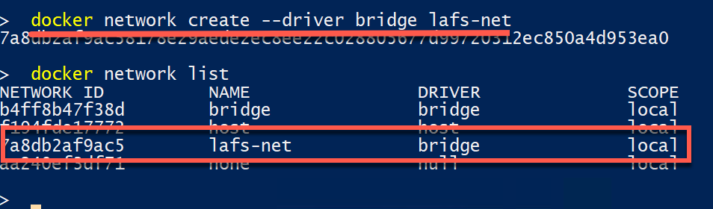

Note: The network list command will show the Docker networks, including the new one you just created.

You have created a virtual network within Docker and given it the name “lafs-net”, which you can now refer to in your containers.

Backend

Docker Compose uses a YAML file to define the services, network, and storage volumes that an application uses. Like the Python programming language, YAML files rely on indentation to group values together. A single compose file can configure one or more containers. For the backend application you will define two services, one for Node JS and the other for MongoDB.

Visit What is YAML to learn more about YAML files.

Refer to the documentation for Compose, and study the proposed file below:

docker-compose.yml

version: '3.7'
services:
# REST API running on Node JS container
app:
container_name: lafs-api
restart: always
build: .
ports:
- '3000:3000'
# link this container to the Mongo DB container
links:
- mongo
# pass in environment variables for database host and name
environment:
- DB_HOST=mongo
- DB_NAME=lafs-db
# Mongo DB storage container
mongo:
container_name: lafs-db
image: 'mongo:4'
ports:
- '27017:27017'
# Attach the external network to these containers
networks:
default:
external:
name: lafs-net

Create a docker-compose YAML file in the top of the project directory and input the above information.

To make certain the REST API application defaults to running against a local Mongo DB instance, update the server/datasources.development.js file to specify default values if not overridden by environment values:

module.exports = {
mongodb: {
connector: 'mongodb',
hostname: process.env.DB_HOST || 'localhost',
port: process.env.DB_PORT || 27017,
user: process.env.DB_USER || '',
password: process.env.DB_PASSWORD || '',
database: process.env.DB_NAME || 'lafs',
url: process.env.DB_URL
}
};

Edit the file by adding the values shown highlighted above.

Now, issue the Docker Compose command in your PowerShell window to bring up both containers:

> docker-compose up

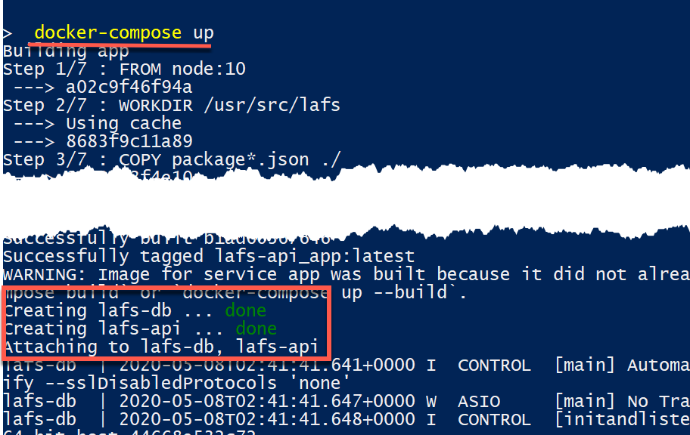

Note: Two containers started and attached to the virtual network.

First, open a command shell inside the Mongo container and see the status of the database after initial startup:

- On the Docker Dashboard app, hover the mouse over the Mongo container entry and click the Shell/CLI icon:

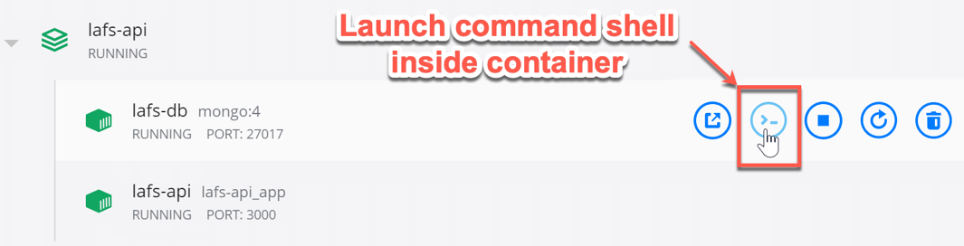

- Now, input the following commands:

> mongo
> show dbs

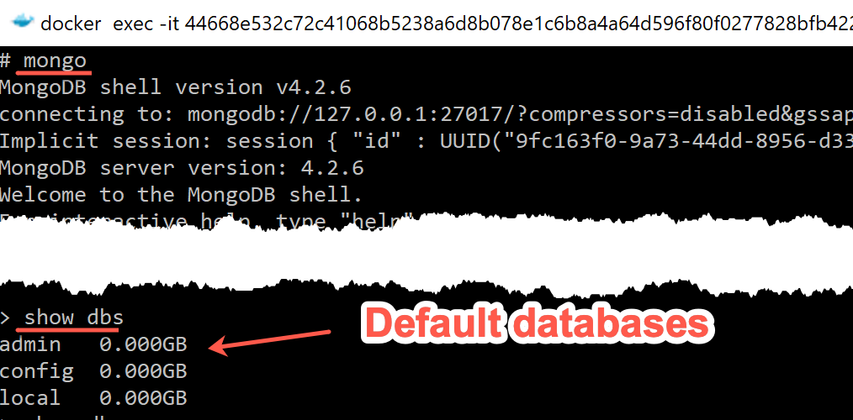

To test these containers, open a web browser and navigate to the LoopBack API Explorer test page:

> http://localhost:3000/explorer

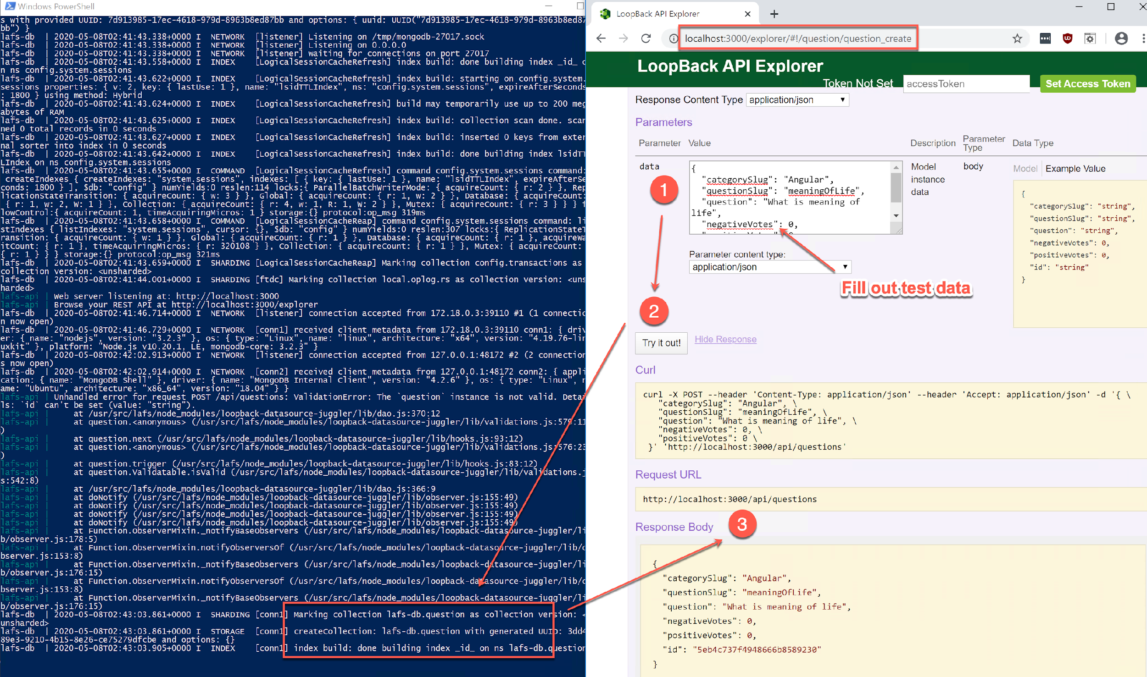

To test the REST API running in the container, complete the following steps:

- Go to http://localhost:3000/explorer/#!/question/question_create and input a test question in the text box labeled Data using information like this:

{
"categorySlug": "angular",
"questionSlug": "what-is-the-meaning-of-life",
"question": "What is the meaning of life?",
"negativeVotes": 0,
"positiveVotes": 0
}

- Click the Try it out! button.
- An HTTP request will be sent to the REST endpoint. You can see in the console window that it was received and processed.
- A successful response is returned with the “id” value populated by Mongo.

Now, return to the Mongo command shell and see what has been stored using the following commands:

> mongo
> show dbs
> use lafs-db
> show collections
> db.getCollection('question').find({})

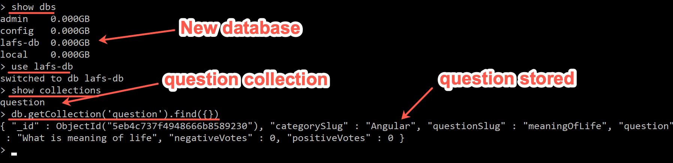

Running a browser on your computer, you tested sending a question to the REST API endpoint running in one container. That Node JS code in turn connected to the second container running MongoDB, where the question was finally stored.

Frontend Development

Because the frontend Angular site is a separate code repository, it is a separate directory on your computer. Therefore, a separate docker-compose YML file needs to be created there to load it into a container. By specifying the same external virtual network, you will communicate with the other two containers. You will see questions and answers that were previously entered shown on the frontend web application.

docker-compose.yml

version: '3.7'
services:
# Angular frontend application
app:
container_name: lafs-web
restart: always
build: .
ports:
- '4200:4200'
command: >
bash -c "npm install && ng serve --host 0.0.0.0 --port 4200"
# Attach the external network to these containers
networks:
default:
external:
name: lafs-net

The Angular tutorial code is written to run against a Heroku cloud instance, so you will need to change the api_url value in src/environments/environment.ts.

export const environment = {
production: false,
api_url: 'http://localhost:3000'
};

Start the container as you did for the backend application. Open a browser and navigate to http://localhost:4200. Choose the Angular category. You will see the following:

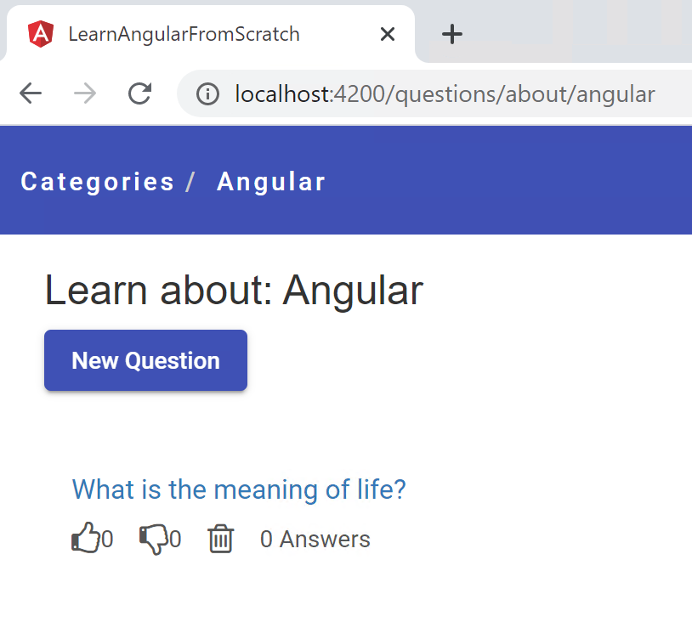

You now have three Docker containers. Each container is isolated from the others yet communicating together. Use the Docker ps command below to see all the container instances running and their configured state. To learn more, visit the Docker PS webpage.

> docker ps -a

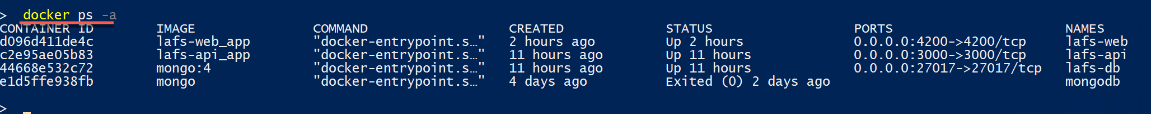

These container images can be deployed to a server in a data center or to a cloud provider and will run there exactly as you have configured them on your computer.

